Kingsley Oti Amponsah
Enhancement Three: Databases
Artifact used: Grazioso Salvare Animal Shelter Project
2/21/2026
Brief
To ease the classification of canines that are eligible for search-and-rescue training, the Grazioso Salvare Dashboard project intends to provide a web interface that is comfortable for users to navigate. To gain access to pertinent data, Grazioso Salvare, an international corporation that specializes in the training of rescue animals, works in conjunction with a non-profit organization that operates an animal shelter in the Austin, Texas. The dashboard gives users the ability to select dogs according to the sorts of rescues they are interested in, read information that is specific to the dogs, and display breed distributions and geographic regions.
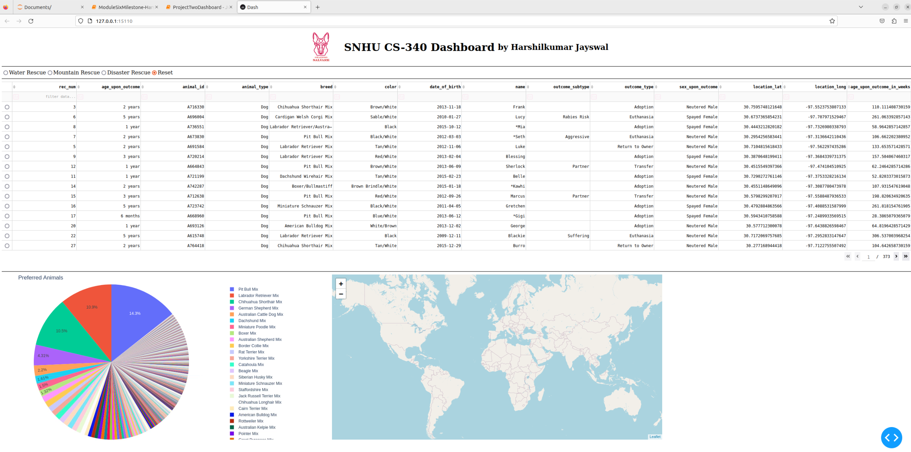
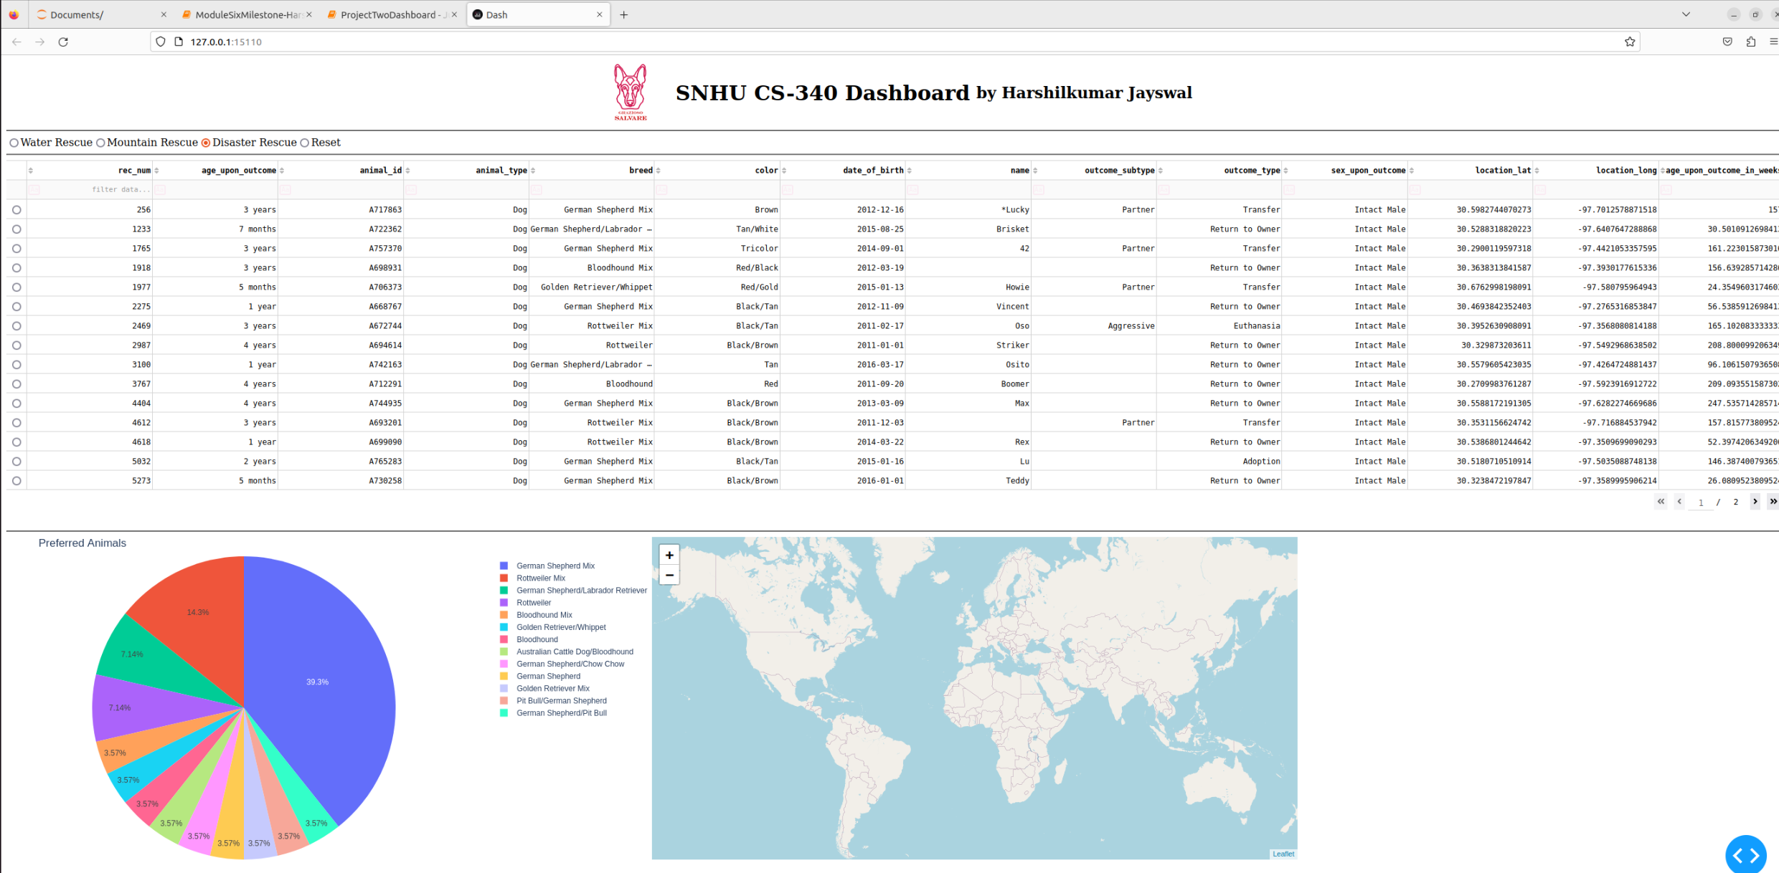
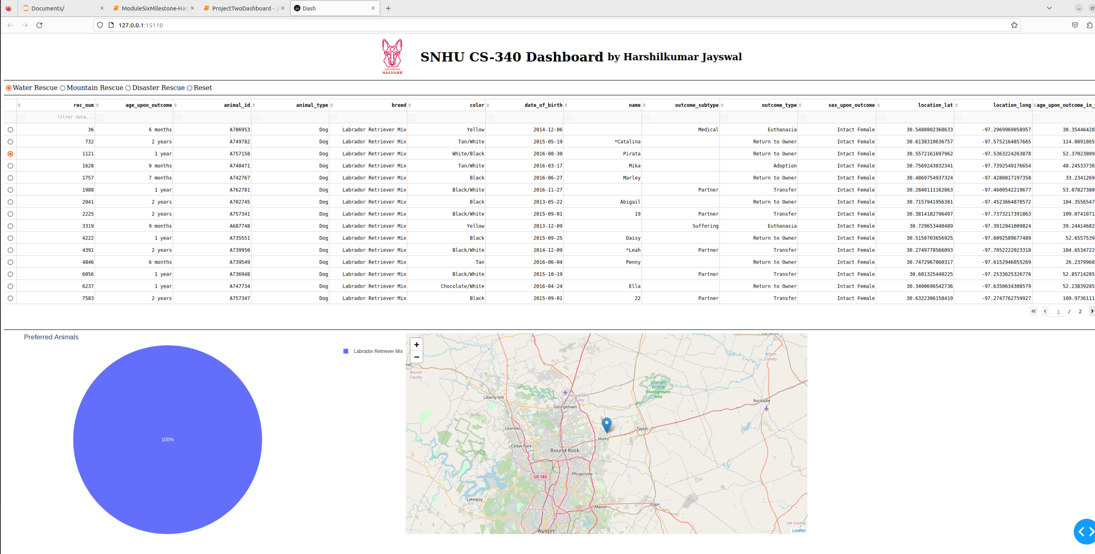
Approach
Tools and techniques used
MongoDB is the database model that is being utilized for this individual project. It is a NoSQL database that offers a number of benefits, including adaptability, scalability, and an easy interface with Python by means of tools such as PyMongo. Its schema-less nature, which enables the storing of data that is both dynamic and unstructured, was the primary factor in its selection. Because of its documents and query language, MongoDB is an excellent choice for managing and querying several different types of datasets.
The Python framework known as Dash is a productive tool for the development of web applications. Through the utilization of Python, HTML, and CSS, it makes it possible to create web-based dashboards that are interactive. Dash was selected because of its ease of use, adaptability, and capacity to connect without any complications with Python data analysis packages such as Pandas and Plotly.
The graphing library known as Plotly is utilized for the purpose of boosting data exploration and presentation by enabling the creation of interactive and dynamic visuals inside the dashboard settings.

Procedures and steps
• Beginning with the Python CRUD module that was established, we now have the capability to connect to databases and perform CRUD operations.
• This is followed by the utilization of the Python Dashboard testing script in order to gain access to our database and present information in a categorized way.
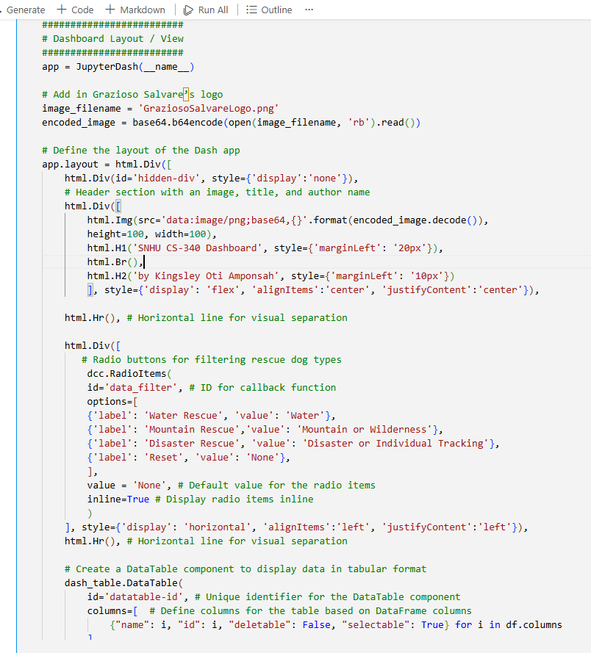
- The HTML Img and H1 elements are used to display the Grazioso Salvare emblem, as well as the title and author information.
- The radio buttons (dcc.RadioItems) provide users the ability to filter dogs according to the sorts of rescues they do. In order to keep the dashboard up to date in response to user selections, callback routines have been built.
There is the dash_table.A tabular representation of the filtered data is displayed by the DataTable component. Sorting, filtering, pagination, and row selection are all possible for user involvement thanks to this feature.
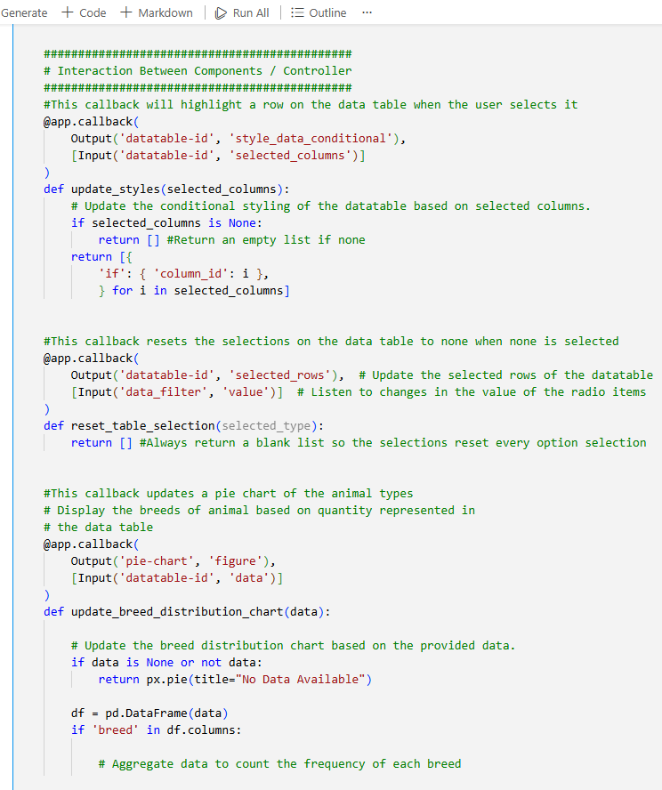
- The components, which are denoted by the dcc.Graph, graphically represent the geographic locations and breed distributions, respectively. Callback routines are responsible for dynamically updating these visuals in response to the actions taken by the user with the data table.
- This function, update_styles(selected_columns), is responsible for updating the style of the selected columns in the data table so that they are highlighted when the user clicks on them.
- This function, update_breed_distribution_chart(data), is responsible for updating the pie chart with the distribution of favored dog breeds depending on the data that has been filtered from the data table.
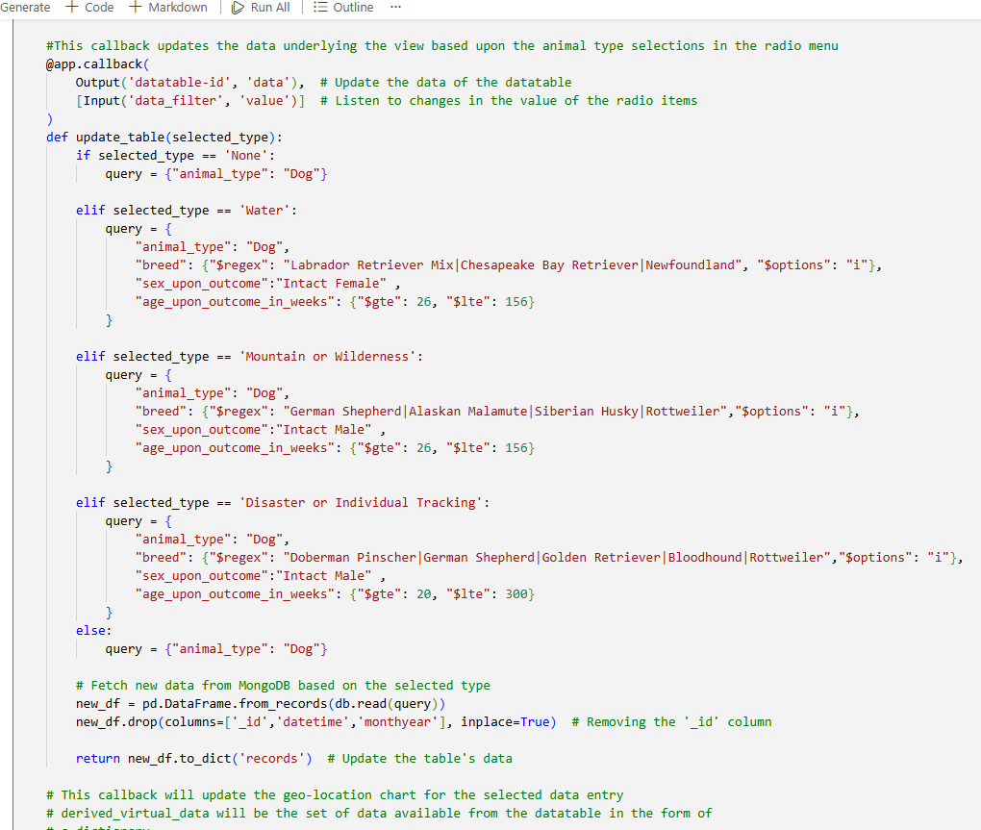

- The update_table(selected_type) function is responsible for updating the data that is presented in the data table based on the rescue type filter that has been selected.
- update_map(viewData, selected_rows) is its name. Brings the geographic map up to date by adding the locations of the dogs that have been chosen from the data database.

Challenges and solutions
• During the implementation of the pie chart visualization, the data labels were dispersed, which resulted in the graphic being extremely distracting and difficult to understand. Through the use of update_traces(textposition='inside'), this issue was rectified. This function modifies the position of text labels within pie chart slices in order to improve their visibility.
• In the database query, the $in operator was only producing precise matches of the breed, which meant that the mixed breeds were not being picked into the pool of candidates. Consequently, the $regex operator was utilized since it enables you to search for documents in which a certain field fits a regular expression pattern. This makes it an effective tool for locating documents that include information that is either incomplete or partial.

